JDBC

**Team Names:**

* Ahmed Nabil Mohamed Anwar (7)
* Ziad Hisham Ali Abdel-Hameed Saad (19)
* Yehia ElSayed Mohamed (59)
* Youssef Ahmed Sayed Gabriel (61)

Report:

**Description:**

* Java Database Connectivity (JDBC) provides Java developers with a standard API that is used to access databases, regardless of the driver and database product. JDBC presents a uniform interface to databases - change vendors and your applications only need to change their driver.

**UML (Design):**

Class Diagram

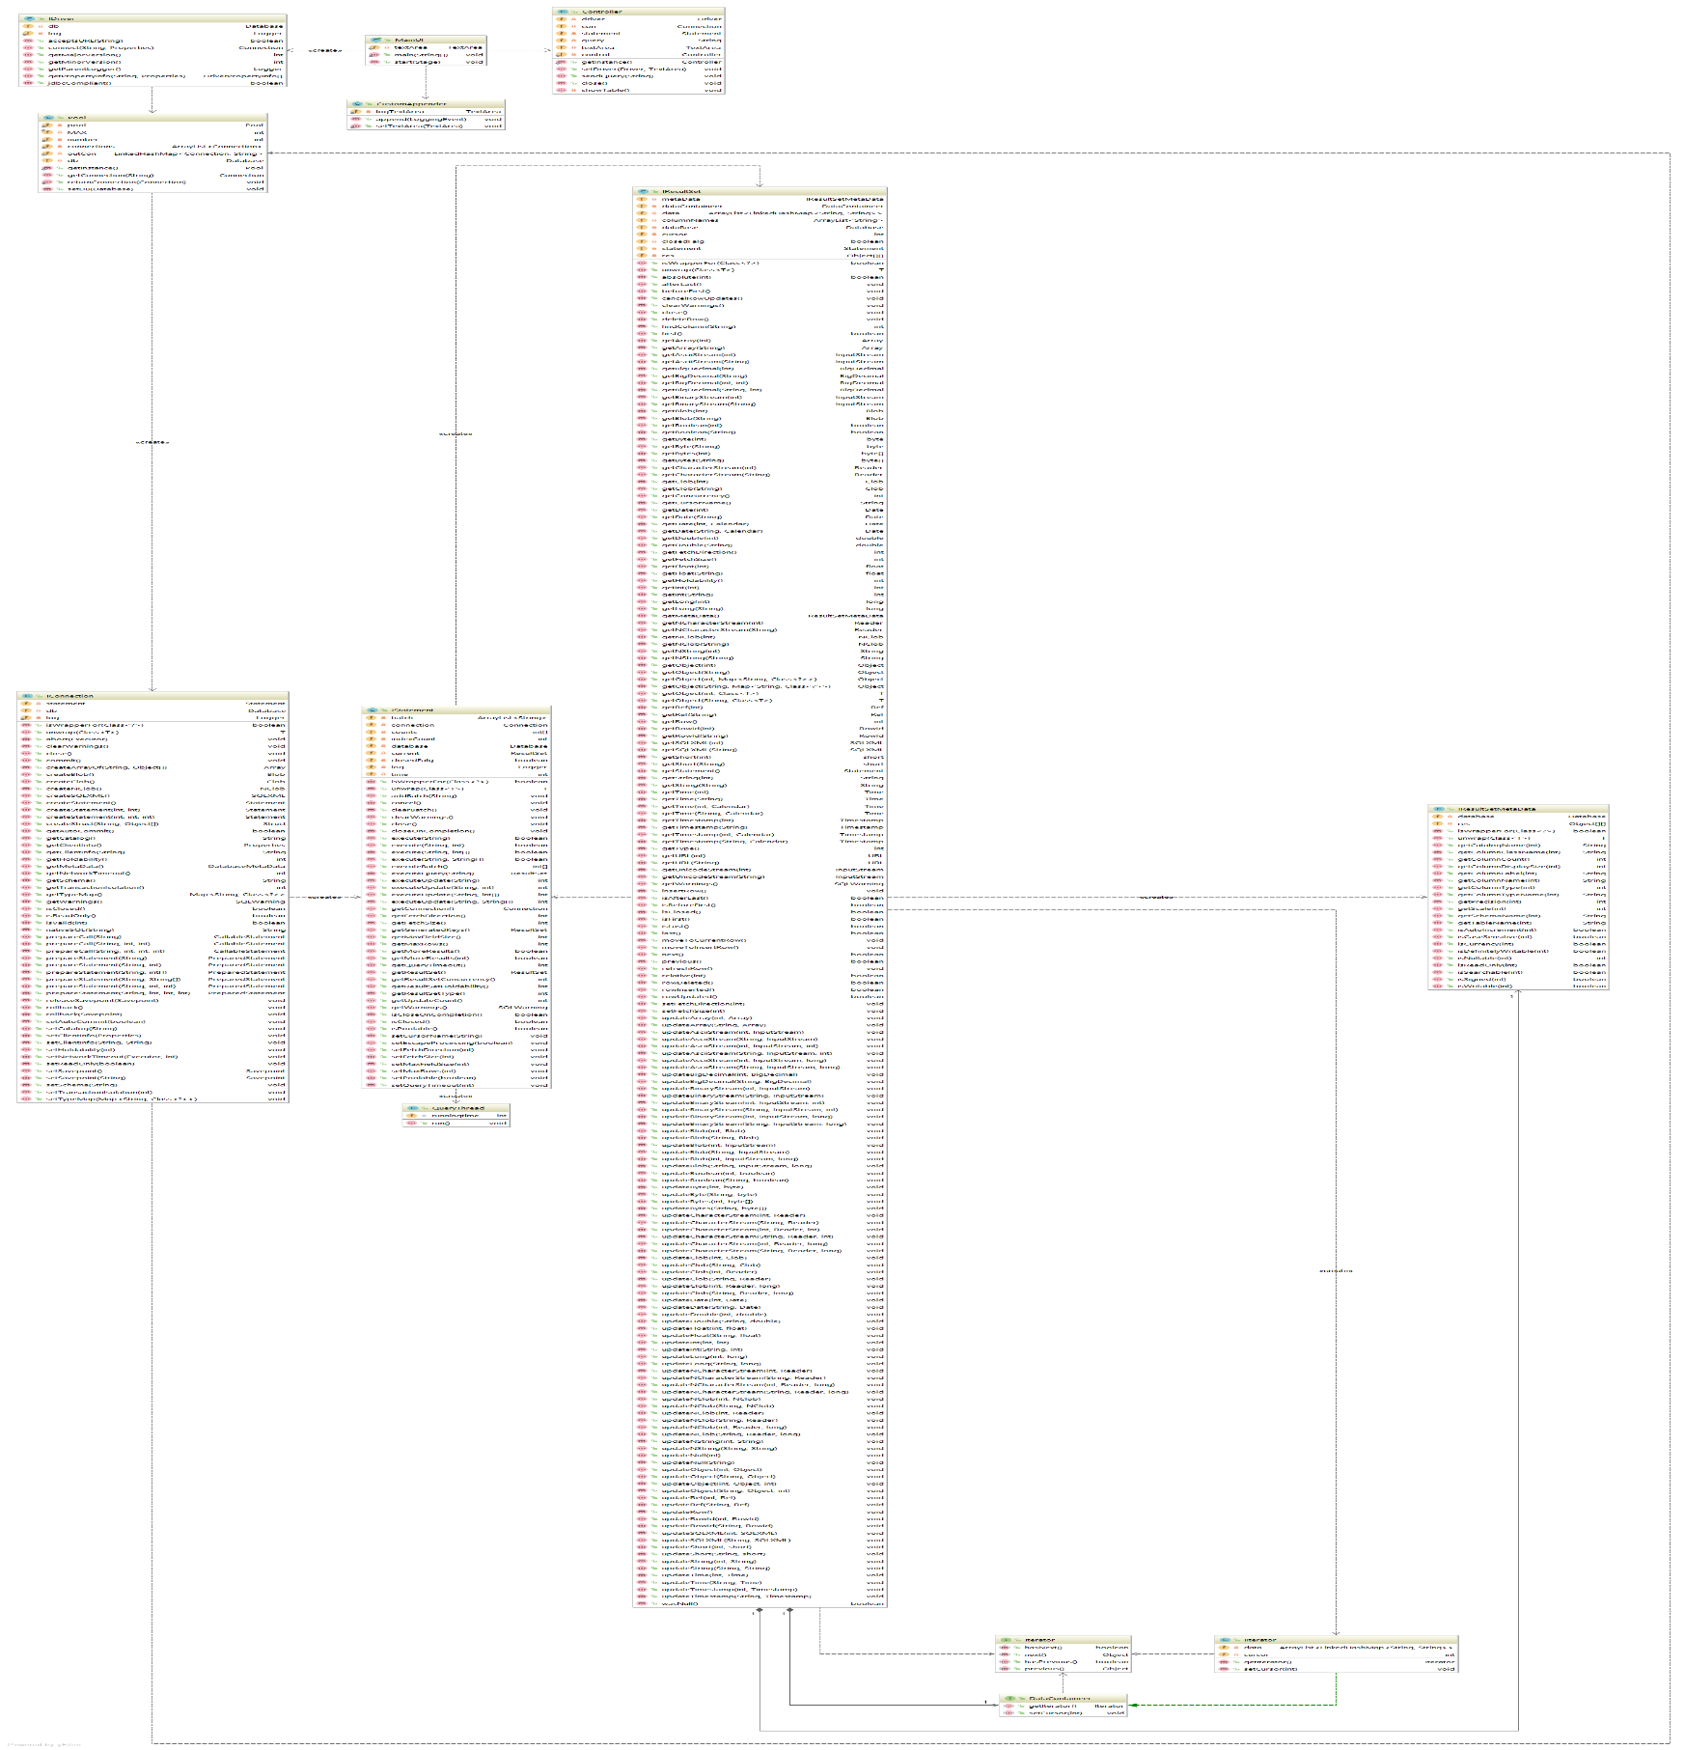

Sequence Diagram

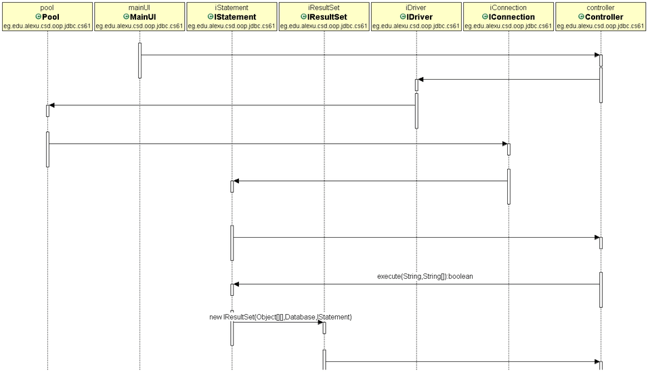

Use Case

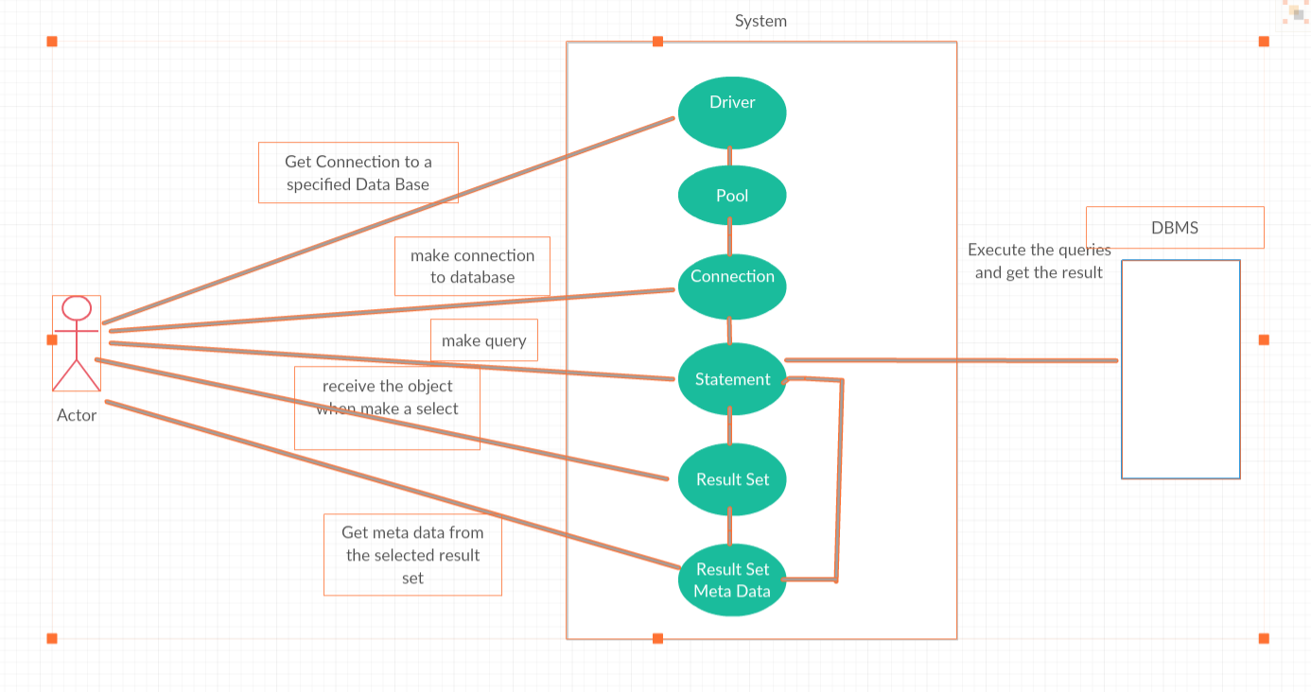

State Diagram of Scenario 1

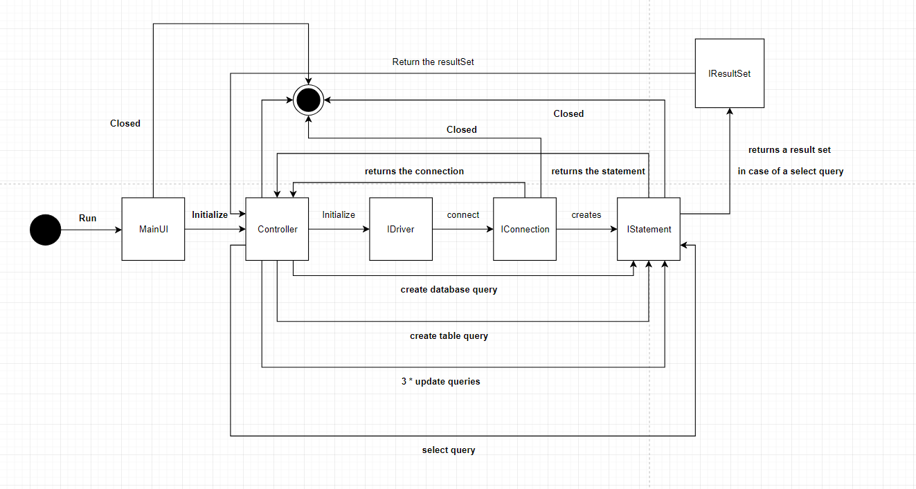

State Diagram of Scenario 2

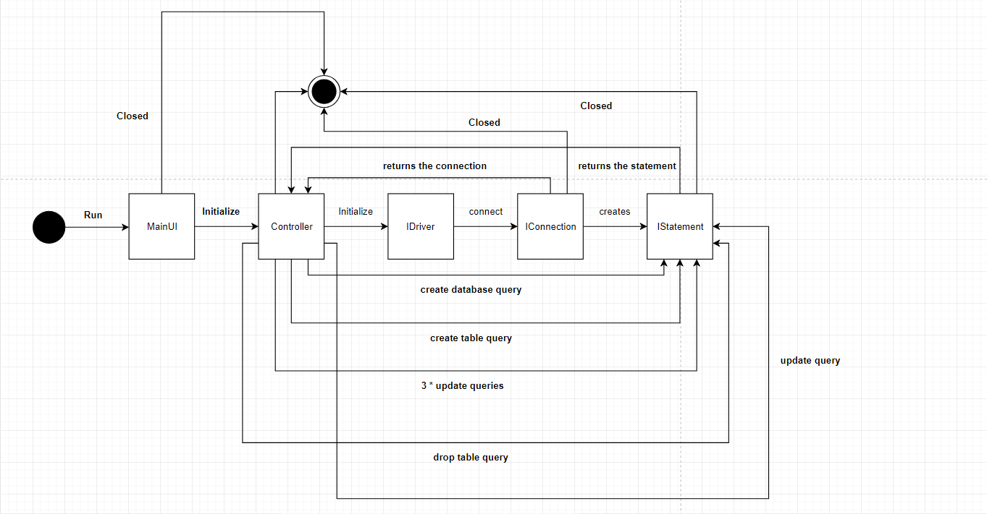

State Diagram of Scenario 3

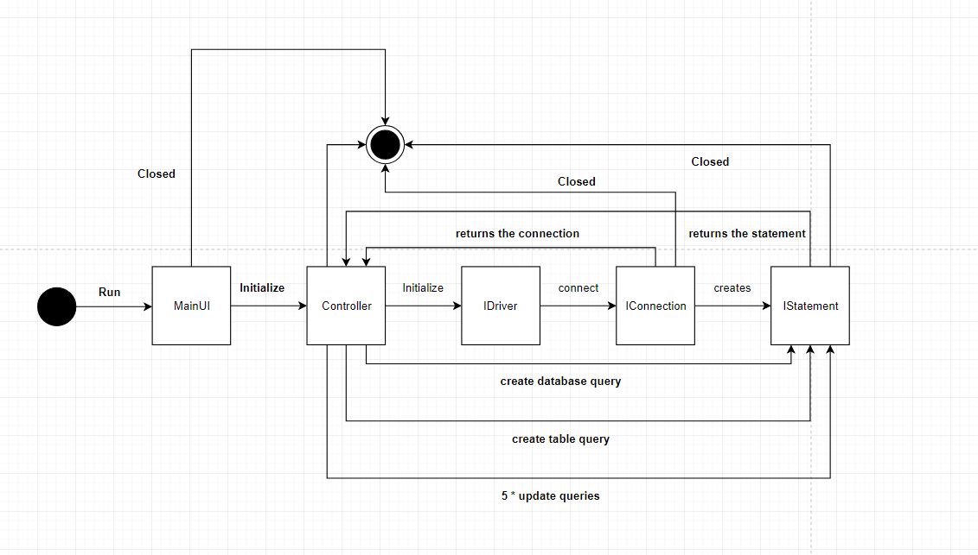

**User Manual:**

* When the application starts, the DBMS driver will start and a connection will be granted to the user if everything is fine.
* The user then will have a GUI with a non-editable text area on which a complete log of what is happening will be shown, and a text field where the user can enter the queries he wants to perform.
* The user should create a database (or just use an existing one) first, then he can create new tables, update the data within these tables and perform select queries on them.
* To enter a query, the user should write it on the text field then press “Enter” from the keyboard.
* If the user enters a select query, a table will appear showing the data that the user has selected.

**Design Patterns:**

* Singleton DP: the connection pool class is singleton as well as the controller class.
* Pool DP: we used it in creating a pool of connections with a limited number of connection for reusability of resources.
* MVC DP: the whole program is structured as MVC.
* Iterator DP: the iteration through the result set is done using iterator design pattern.

**Labor Division:**

* We first divided the required interfaces upon us and read their documentations.
* Then, each one took an interface and made the concrete class of it.
* Then, the GUI, report and UML diagrams were made as a group.
* We took turns on the debugging of the errors.

**Screen shots:**

